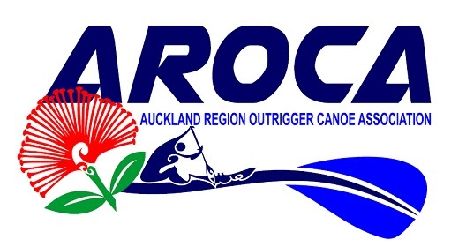
Date: 19th March 2020
Kia Ora Koutou

We are pleased to publish the results for the AROCA Long Distance Championship held March 7th 2020 at Okahu Bay.
Please accept our sincere apologies for the delay, and for any errors in placings on the day.
We experienced some technical issues with the timing device and therefore had to revert to our manual paperwork and feedback from clubs and paddlers.
From this data we were able to arrive at the current placings for teams and paddlers but regrettably due the extremely close finish for some of the teams, particularly in race 1 we were not able to record some of the times. These will show as NR (Not Recorded).
Please note:
Some categories were combined due to less than 3 entries in the original category. W1 categories have been modified to show rudder/rudderless. These updates have in some cases changed the results and placings. Those teams and paddlers who were not officially recognised on the day will now be awarded medals.
Individuals have the choice to receive their medal in the post or at our next event medal ceremony (Regional Sprints - Dec 2020)
Please see the attached and contact us if you have any concerns.
Nga Mihi
Aroca

